

School of Computing Science and Engineering
B.Tech (CSIT/CSSE/IOT/ISE)
Course Code: |  |  | Major Project Progress Report – Phase 2 Review 1 |  |  | Academic Year:2025-2026
 |  |  |  |  |  | Semester: 8th
Project Group Members Details
Group No: C25 |  | Group Name: AgriSmart
Sl. No | SRN | Full Name |  | Sec | Mobile No. | Email_ID |  | Sign
1 | R22EJ066 | VINAY R |  | B | 6363808973 | vinayr4you@gmail.com
2 | R22EJ067 | VISHWAS B A |  | B | 7483672637 | vishwagowda2004@gmail.com
3 | R22EJ068 | YASHAS S |  | B | 8431117501 | yashas1042004@gmail.com
4 | R22EJ069 | YASHWANTH GOUDA S |  | B | 7892136488 | syashwanthgouda@gmail.com
Task Distribution
Project Leader |  | Yashwanth Gouda S
Documenter Lead: |  | Vishwas B A and Yashas S
Development Lead: |  | Vinay R and Yashwanth Gouda S
Project Details
Project Title: |  | Smart Crop Advisory System for Small and Marginal Farmers
Type of Project |  | Web Application with AI
Guide Details: |  | Name: Dr. Chatrapathy K  Designation: Professor |  |  |  |  | Mobile No:  7619441891
Place of Project Work: |  | Reva University
Remarks by Guide: |  |  |  |  |  |  | Guide Signature  Date:

Contents

- Project Implementation.
  - Architectural Design, Circuit Design (Hardware Project) and Mechanical and Control Unit Design (Robotics or automation projects)
  - Class Diagram
  - Entity Relationship Model
  - Sequence Diagram
  - Description of Technology Used
- Conclusions
- References

- Project Implementation

1.1 Architectural Design
The Smart Crop Advisory System (SCAS) is designed using a multi-layered architecture to ensure scalability and modularity.

System Architecture:

User Device (Mobile/Web)
↓
Frontend (React.js / React Native)
↓
Backend APIs (Node.js / Express.js)
↓
ML Services (Flask/FastAPI for Python ML models)
↓
Database (MongoDB Atlas)
↓
External APIs (OpenWeatherMap, Market Price API)

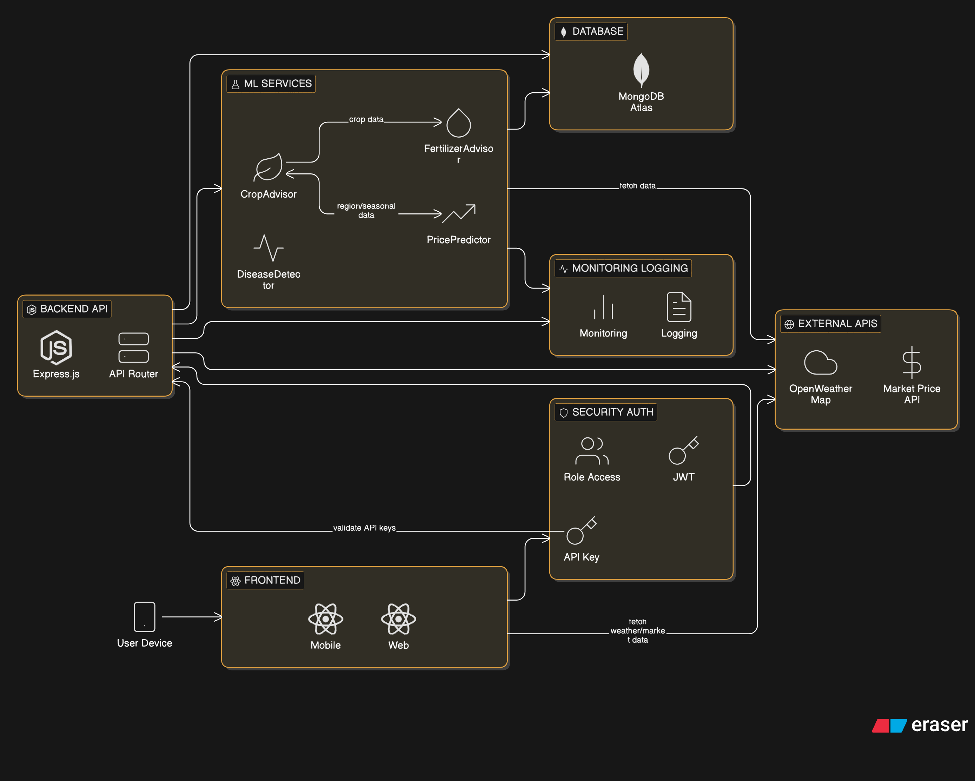

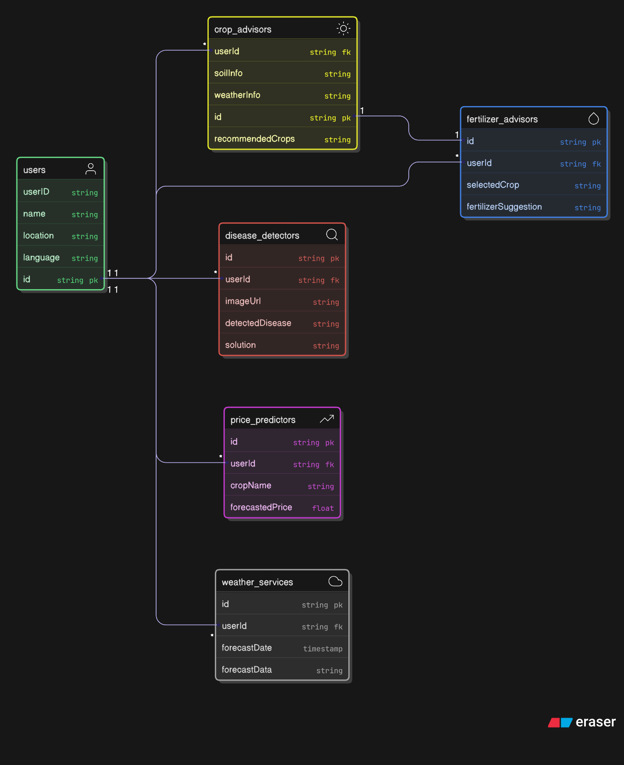

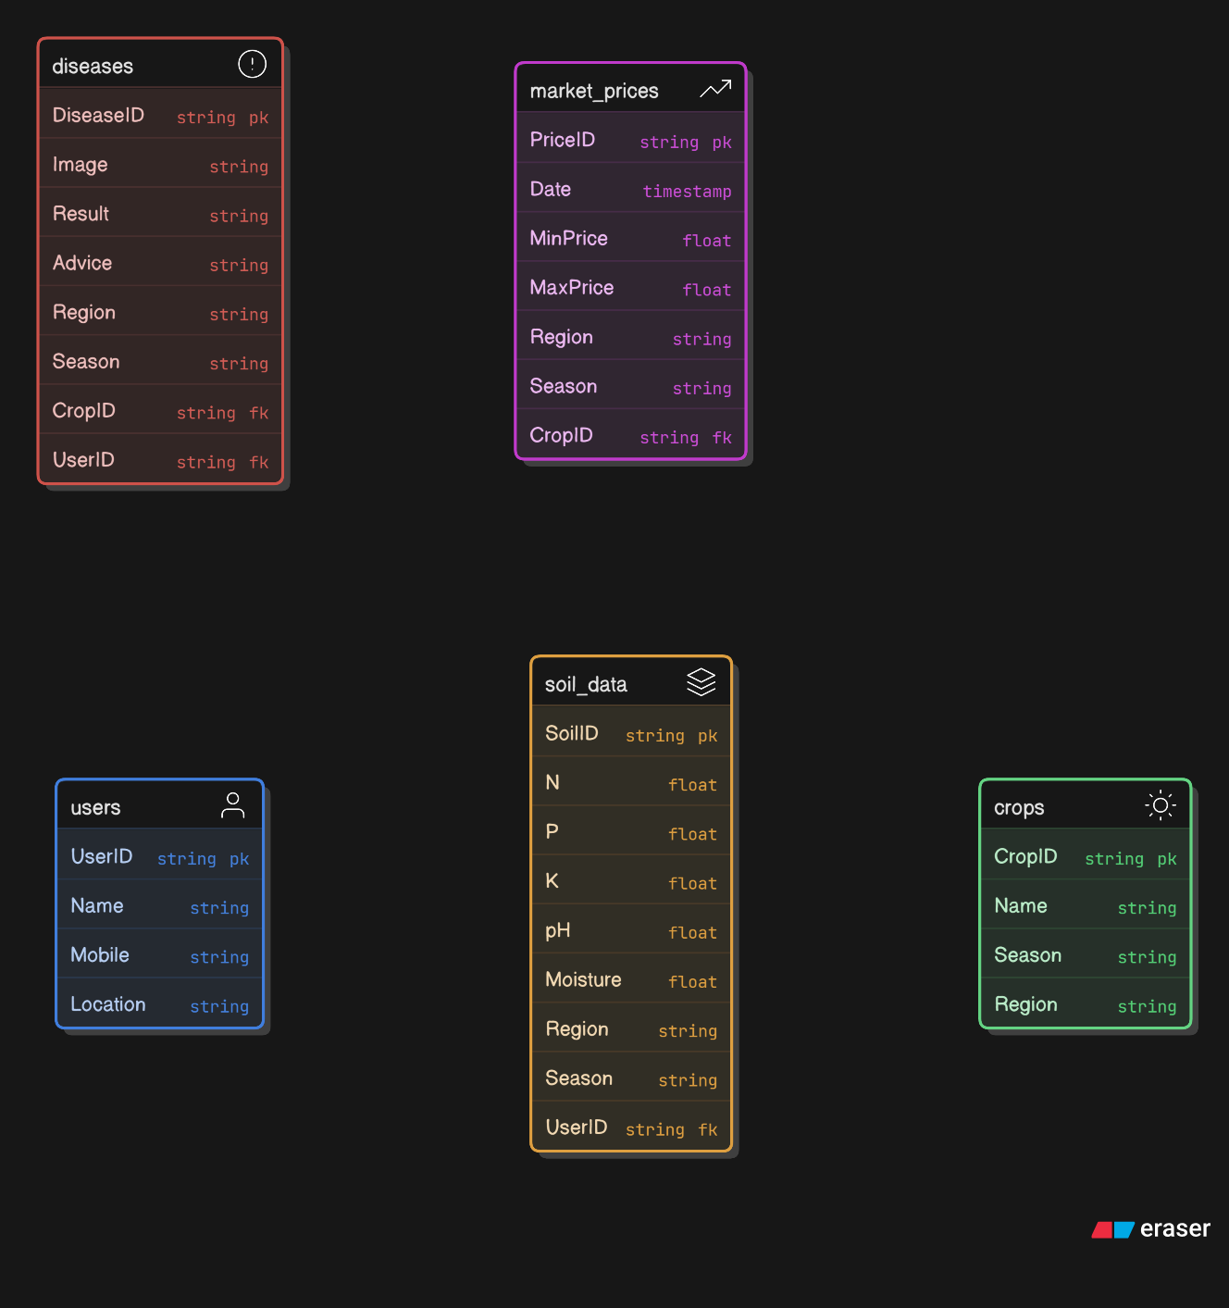

Description of Technology Used
- Languages: Python (ML), JavaScript (Frontend, Backend)
- Frameworks: Flask, FastAPI, Node.js, Express.js, React.js, React Native
- ML Libraries: Scikit-learn, TensorFlow, PyTorch
- Database: MongoDB Atlas (NoSQL)
- External APIs: OpenWeatherMap, Google Translate, Government Agri Portals
- Cloud: AWS EC2 (deployment), GitHub (version control)
- Tools: Postman, Figma (UI), Colab (training models)

2. Conclusion
The Smart Crop Advisory System empowers small and marginal farmers by offering AI-based solutions for crop selection, fertilizer advice, weather alerts, disease detection, and market forecasting. The project demonstrates the successful integration of machine learning models with user-centric interfaces. By utilizing modern web technologies and cloud deployment, the system ensures accessibility, scalability, and reliability. Future scope includes IoT sensor integration and support for regional dialects.

3. References
- Y. Tagawa et al., "AI-Based Agriculture Application for Crop Recommendation and Guidance System for Farmers," IC3SE, IEEE, 2024.
- IJERT, "Smart Crop Advisor Using ML," vol. 13, no. 4, 2025.
- OpenWeatherMap API Documentation, [Online]. Available: https://openweathermap.org/api
- TensorFlow Documentation, Google, [Online]. Available: https://www.tensorflow.org
- Scikit-learn Developers, "Machine Learning in Python," [Online]. Available: https://scikit-learn.org
- MongoDB Atlas Docs, [Online]. Available: https://www.mongodb.com/cloud/atlas
- Indian Ministry of Agriculture, Digital Agri Portal, 2024.

- Project Implementation
Your project group is required to submit a document outlining the project's implementation details.
  - Architectural Design: Component diagrams, high-level descriptions of the components in your system, and their purpose in relation to the project’s objectives.
  - Class Diagram: Outlines the attributes, methods and interactions of the major classes/modules in your system.
  - Entity Relationship Model: Specifies the entities, datatypes, and relationships that are important for the project domain.
  - Sequence Diagram: Illustrates object interactions for the major use case scenarios for the project.
  - Description of Technology Used: Hardware devices, software products, programming languages.

Ensure that your diagrams follow proper modelling conventions. Include appropriate write-up to connect the sections. Overall, your document should have a smooth flow, logical transitions, and should be easy to follow.

- Conclusions:
A conclusion is the last part of something, it means "finally, to sum up," and is used to introduce some final comments at the end of writing.

- References:

References must be quoted as per the following format:

Author(s) Initial(s). Surname(s), “Title of Report,” Abbrev. Name of Co., City of Co., Abbrev. State, Country (abbrev. US State or Country if the City is not 'well known'), Report number/Type (if available), Abbrev. Month. (Day if available), Year of Publication.

Example for reference is given below. Kindly follow the same format for writing reference

- G. Eason, B. Noble, and I. N. Sneddon, “On certain integrals of Lipschitz-Hankel type involving products of Bessel functions,” Phil. Trans. Roy. Soc. London, vol. A247, pp. 529–551, April 1955.
- J. Clerk Maxwell, A Treatise on Electricity and Magnetism, 3rd ed., vol. 2. Oxford: Clarendon, 1892, pp.68–73.
- I. S. Jacobs and C. P. Bean, “Fine particles, thin films and exchange anisotropy,” in Magnetism, vol. III, G. T. Rado and H. Suhl, Eds. New York: Academic, 1963, pp. 271–350.
- K. Elissa, “Title of paper if known,” unpublished.
- R. Nicole, “Title of paper with only first word capitalized,” J. Name Stand. Abbrev., in press.
- Y. Yorozu, M. Hirano, K. Oka, and Y. Tagawa, “Electron spectroscopy studies on magneto-optical media and plastic substrate interface,” IEEE Transl. J. Magn. Japan, vol. 2, pp. 740–741, August 1987 [Digests 9th Annual Conf. Magnetics Japan, p. 301, 1982].
- M. Young, The Technical Writer’s Handbook. Mill Valley, CA: University Science, 1989.

